How to Write Your Paper for the JSET Research Reports

Taro Nihon* Jiro Kyouiku* Hanako Kougaku**

*Nihon Kyouiku University
**Nihon Kougaku University

Abstract The Japan Society for Educational Technology holds a national conference twice a year. Manuscripts of presentations are published as "Proceedings of the Japan Society for Educational Technology". Manuscripts should be written according to this manuscript template. Manuscripts must be submitted online in PDF format by the deadline after checking the "発表について" section on the conference website. Manuscripts should be written with due consideration for the copyrights of others and the privacy and honor of the individuals or groups involved in the research (individuals or groups who were the participant of the research or who are related to the research).

Keywords Educational Technology, National Conference, Manuscript Template

1. Introduction
The Japan Society for Educational Technology (JSET) National Conference on Educational Technology allows the presentation of research related to educational technology. Submitted files will be checked by the Conference Planning Committee, which may request revisions as necessary, but will not, in principle, respond to personal requests for replacements.

2. Preparation and Submission of Manuscript Files
Manuscripts should be submitted on A4-size vertical paper, one page per sheet. Manuscripts should two pages and those with one or more than three pages (like this template) will not be accepted. No page numbers are assigned. Each manuscript file should be submitted in PDF/X-1a format so that the electronic file of the proceedings can be created in a way that makes it possible to search for text in the text of the paper.
Since the positions of figures, tables, and captions may be moved to unintended locations during PDF creation, print and check the created PDFs before submission. If you are not sure whether the fonts are embedded in the PDF, use common fonts and character codes. Some character codes may not be searchable.

3. requests and notes on manuscripts
Manuscripts should be complete at a certain level. The conference planning committee reserves the right to request revisions to the style of writing, such as "The results will be presented at the conference venue on the day of the conference. It is not acceptable to submit similar or series of papers to multiple presenters.
The publication date of the Proceedings is the date when the papers become available for downloading by those who have submitted their papers in advance. In addition, the authors are requested to give permission for the JSME to publish the submitted manuscripts on the JSME website. Other details of manuscript preparation are as follows.
3.1 Manuscript Layout
Manuscripts prepared in Word may use a manuscript template. For manuscripts prepared in other formats, the following settings should be used.
The margins should be set to "30 mm at the top, 25 mm at the bottom, and 30 mm on the left and right sides. The beginning of the manuscript should be set to "1 column, 42 characters per page, 50 lines per page". On the other hand, the body should be set to "2 columns, 20 characters per line, 50 lines per page". Headers and footers should not be added.
Table1 sample table
人数 | 引用表記
１人 | （教育 2008）および  （Kyouiku 2008）
２人 | （教育・工学 2008）および  （Kyouiku and Kougaku 1992）
３人以上 | （教育ほか 2008）および  （Kyouiku et al. 2008）

Titles should be written in Times New Roman, 16pt. The authors' names and affiliations should be written in Century, 10pt. No subtitle should be added.
3.2 Introduction and Keywords
The abstract should begin with Abstract, followed by a single space, and should be approximately 100 words in length. The abstract should be separated by one line from the English affiliation. Keywords should be written as Keywords, followed by a space and a list of three key words.
3.3 Main text
Punctuation should be indicated by a comma (,) and a period (.). The text should be written in 10pt Century.
3.4 Chapter, Section, and Article Headings
Before each chapter heading, there should be a blank line between the chapter heading and the last line of the previous chapter. However, this does not apply when a chapter or section begins at the beginning of a page or column, or for section headings. Headings should not begin at the bottom of a column. In such cases, they should begin on the next column or page.
Chapter should be in Times New Roman, 12pt. Section, and paragraph headings should be in Century, 10pt.
3.5 Figures and tables
Each table and photograph should be numbered and titled as shown in Figure 1 and Table 1, respectively. Figures and photographs should be centered directly below and tables directly above. Captions for "Figures," Use spaces between figure/photo numbers and titles, and do not use ":" or similar characters.
Figures and photographs should be of sufficient size and clarity. Figures and photographs should be displayed in color.
3.6. Format of References List
References should be listed in alphabetical order by author's surname at the end of the manuscript. Only references cited or referred to in the text should be listed here.
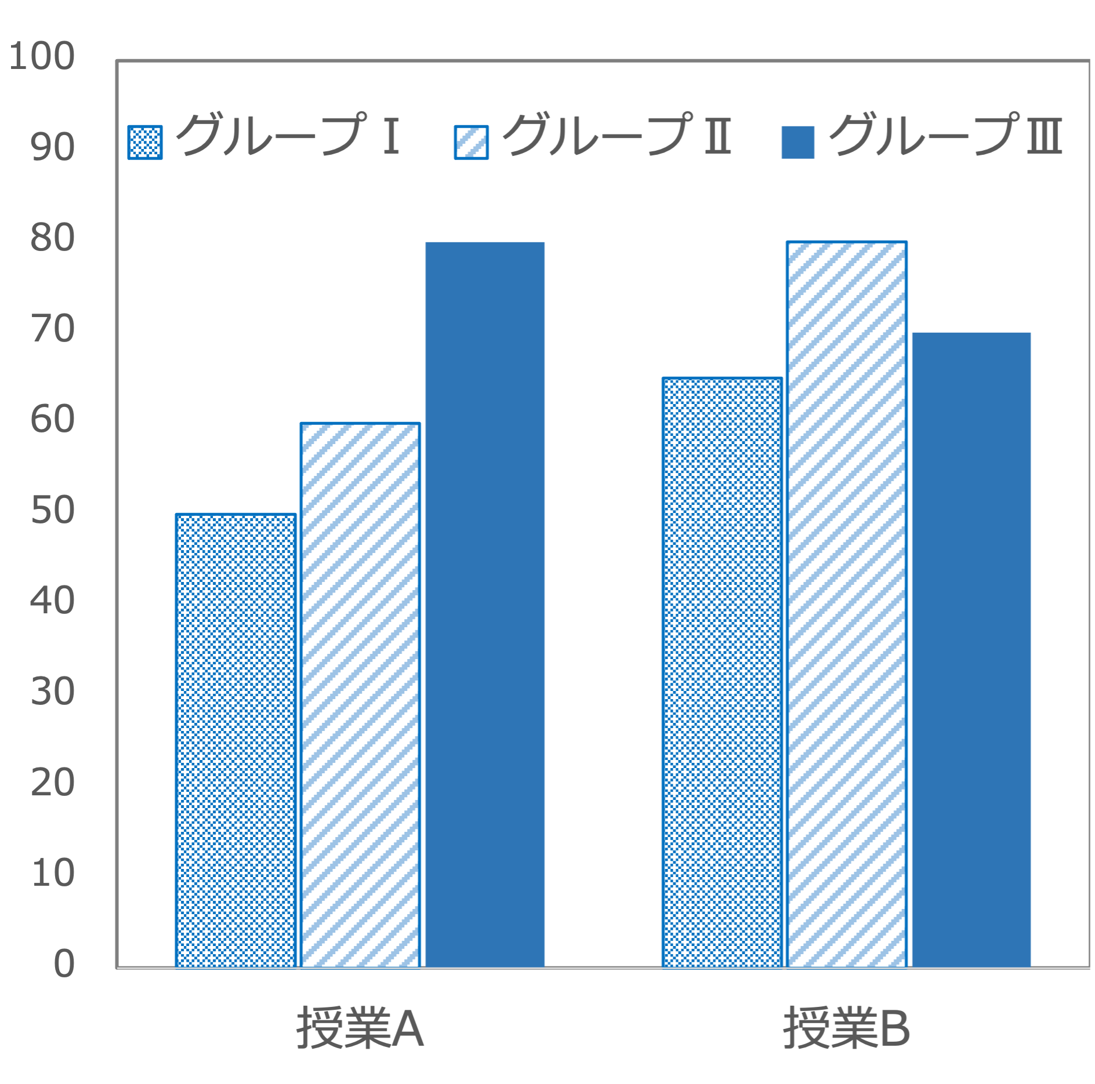Figure1 sample figure
In the case of a journal, the following order should be used: author(s), year of publication, title, journal name, volume number, issue number, and page(s) where the article is located. Journal names written in English should be italicized.
In the case of a book, it should be in the following order: author, year of publication, title, publisher, place of publication, and (page(s) if pages are included). Names of books written in English should be italicized. Note that some societies may use a notation method other than Vol. and No..
URLs (Uniform Resource Locator) should be referenced in the following order: author, publication year, title, URL, and reference date. URLs may be automatically hyperlinked by word processing software, but the hyperlinks should be removed.
Connect the start page number and the end page number with a one-byte - (hyphen) character.
If a bibliography is more than two lines long, indent the second and subsequent lines by four one-byte characters.

Note:
1) Manuscripts submitted by e-mail will not be accepted in principle.
2) If you have difficulty using MS fonts, use equivalent fonts.

References
Kougaku, H., Gakkai, Y. and Kyouiku, J. (2009) Educational Technology and it’s Methods. In Gakkai, Y. and Kyouiku, J. (Eds.) Educational Technology, Kougaku University Press, pp.1-10, New York
教育次郎 (2008a) 教育工学の展望．日本教育工学会論文誌，31(3)：1-5
教育次郎 (2008b) 教育工学．工学出版，東京
Kyouiku, J. (2008a) Educational Technology and it’s Methods. https://www.jset.gr.jp/en/（参照日2022.01.02）
工学花子，教育次郎 (2021) 研究会発表原稿の書き方．日本教育工学会研究報告集，JSET2021-1, pp.100-104

